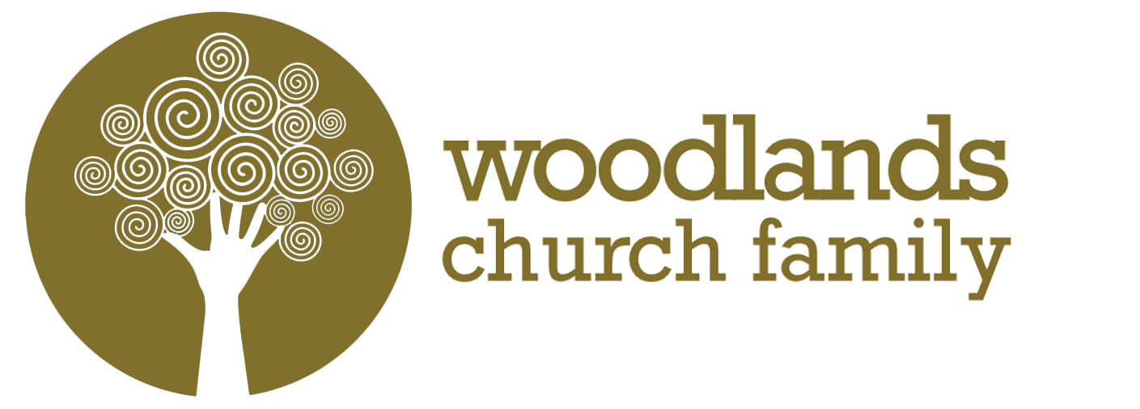
Discipleship Year Application Form
Please complete all of the appropriate sections on this form by typing your answers and then emailing it to the person/s detailed at the end of the form.

1. PERSONAL INFORMATION

Surname: First Name(s): Title:

Address (including postcode):

Telephone: Home Work Mobile

Email Address:

2. EDUCATION, QUALIFICATIONS AND TRAINING

Name of school/college/university | From | To | Full details of qualifications gained, including subjects, grades, class or division.

3. EMPLOYMENT DETAILS
If applicable, please give details of any employment

Job Title | Employer | Start & Finish Dates | Responsibilities

4. ADDITIONAL INFORMATION in support of your application

Please give a brief description of yourself i.e. personality and character.

What are you doing at present (college, university, job, unemployed etc)?

How long have you been a Christian?

Which church/congregation do you attend?

Describe any positions of responsibility which you hold/have held within the church/Christian Union/youth group.

Why are you interested in joining the Discipleship Year at Woodlands?

What do you hope to gain from the Discipleship Year?

Which particular areas of ministry (eg children, youth, students, worship, tech etc) or Geographical area (eg Sea Mills, Southmead, South Bristol etc) would you like serve in and grow in during the year?

What do you intend to do after completing the Discipleship Year?

Do you have a current DBS check? Yes  No 

Have you ever been convicted of a crime, apart from a minor traffic violation? Yes  No 
If yes, please specify.

5. REFERENCES

Please provide the names and addresses of two referees. Give the status of each person named, including one church leader and one personal referee:

Referee 1
Name:
Address:
Telephone:
Email:
Occupation/Title:

Referee 2
Name:
Address:
Telephone:
Email:
Occupation/Title:

6. DECLARATION

I certify that the details in this application are correct.

Signature of applicant:

Date:

Please return to your application to our Academy Lead, Tim Dobson at tim.dobson@woodlandschurch.net, copying the congregational leader (if you are part of the Woodlands Church Family).

