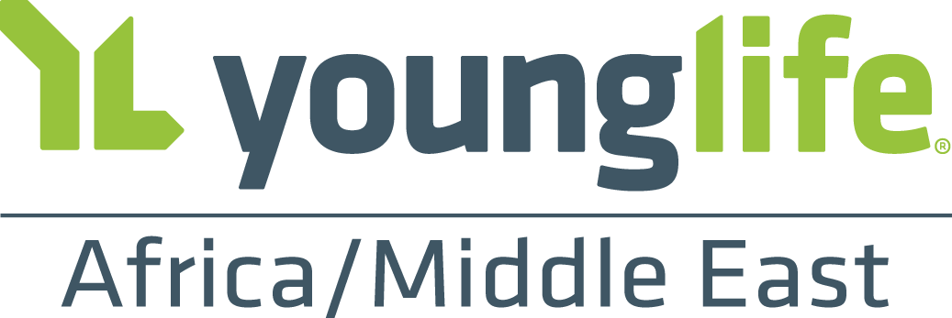

Young Life - Kenya Mission Trip
December 2017

What is Young Life?
Young Life is a global missions organisation with a mission of introducing adolescents to Jesus Christ and helping them grow in their faith. To achieve our mission, our teams build Christ-centered leaders for the next generation in Kenya. These Kingdom leaders pour themselves into kids, transforming them to serve in church, education, business, healthcare, politics: every sector of society. We believe the hope for Kenya is change from the inside out, a change that will be ushered in by these Jesus-centered leaders.

The videos below will give some insight into the heart and vision of the ministry all over Africa and in Kenya.

Young Life Camp Videos:
- Transformation at Camp: https://player.vimeo.com/video/205961805
- Made for Africa: https://player.vimeo.com/video/93435976

Young Life Kenya Ministry Overview:
- https://vimeo.com/channels/younglifeafrica/173186738

What is the purpose of the trip?
There are two parts to the trip. The first part will be serving as the work crew for the Young Life Football Camp near Nairobi. The second part of the trip will be a work project at a school in Nairobi. In addition, we may be able to visit an Orphanage in Kahawha West.
How much does it cost?
- Ground Costs: ~£1100 + Airfare (~£900 to £1000)
  - Ground costs include meals, lodging, private ground transport, and funding for camp and work projects.
- A one day optional safari is an additional £150 (paid separately)

How do I pay for the trip?
Most people pay for a portion of the trip themselves and fundraise for the remaining portion. Our desire is to equip you to raise money through contacting friends and family and inviting them to partner with you in your mission trip.

The goal is for the trip to be 70% funded by November 1st to pay for the airfare and 100% funded two weeks before departure.

What is the itinerary?
While this is subject to change, the expected schedule is:
Dec 27 Travel to Kenya
Dec 28-Jan 1 Young Life Soccer Camp Work Crew
Jan 2-3 School/Community Projects
Jan 4 Safari (optional)
Jan 5, 6 Travel Home

How many people are going?
The trip is limited to 15 people. The trip minimum is 6. Our goal is to create a combined team from Woodlands and a church in the US (River Ridge Church) where Jason Hager was on staff before joining the Young Life Africa team.

How will we prepare for the trip?
Ideally, we will meet 3 to 4 times before departure for team building, fundraising instruction, and cross culture training.

Where will we stay?
At the football camp, we will stay in a former boarding school. In Nairobi we will stay at the Young Life guest house in Kahawha West.

Do I need to get any shots?
You will need to get shots before going to Africa if you have not had them previously. You can consult your GP or the UK equivalent to the Center for Disease Control (CDC) to determine what shots you need. You will also need malaria medication (in pill form). Costs for medication and shots will vary depending on insurance.

Will we do anything “touristy”?
We will take a one-day safari where we will have the opportunity to see elephants, giraffes, lions, warthogs and other African animals. The safari cost is approximately £150. We will also shop in local markets.

How do we get there?
Most likely, we will fly from Bristol or London to Nairobi.

Is it safe?
There is a safety risk traveling in any foreign country or large city, but we are very cautious in our travels. There is always a native Kenyan with us when we travel and we use private transportation. We do not intentionally go in areas that are unsafe. We are monitored by the Young Life Expeditions Team in the USA. We also constantly monitoring the US State Department web site.

How do I sign up or ask further questions?
Contact Jason Hager at jasonhager@RiverRidge.org or via mobile at 07494 284 237.
Sign up deadline is October 8 so don’t delay .

